LAB ASSIGNMENT 4 (UG/02/BTCSEAIML/2023/065)
Wap in C in linux terminal to create a Zombie process using fork().
Answer:
What is a Zombie Process?
- When a child process finishes but the parent has not called wait() yet
- The child becomes a Zombie — it is dead but still exists in the process table
- It stays there until the parent reads its exit status using wait()
Child finishes → Parent doesn't wait → Child becomes ZOMBIE
#include <stdio.h>
#include <unistd.h>
#include <sys/wait.h>

int main() {
pid_t pid;

// Fork a child process
pid = fork();

if (pid < 0) {
printf("Fork failed\n");
return 1;
}

else if (pid == 0) {
// ===== CHILD PROCESS =====
printf("Child Process\n");
printf(" My PID : %d\n", getpid());
printf(" Parent PID : %d\n", getppid());
printf("Child: I am done! Now I become a Zombie...\n");
// Child exits but parent doesn't call wait()
}

else {
// ===== PARENT PROCESS =====
printf("Parent Process\n");
printf(" My PID : %d\n", getpid());
printf(" Child PID : %d\n", pid);
printf("Parent: I am sleeping and NOT calling wait()...\n");

// Parent sleeps for 30 seconds WITHOUT calling wait()
// During this time, child is a ZOMBIE
sleep(30);

printf("Parent: Now I will collect the zombie child\n");
wait(NULL); // Finally collects the zombie
printf("Parent: Zombie child collected!\n");
}

return 0;
}

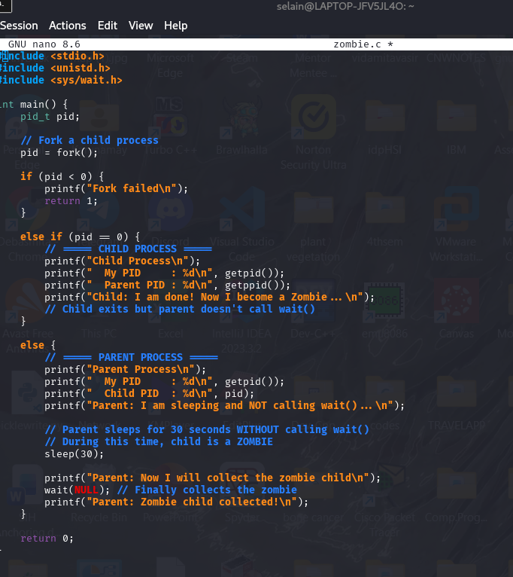

Opening 2 terminals to check the zombie state of the child process.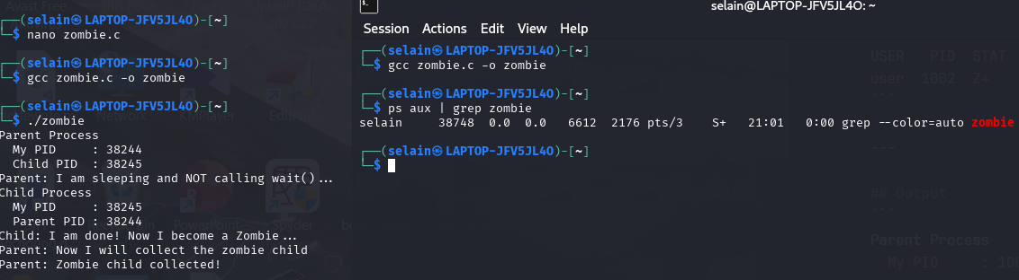
Parent Process
My PID : 1001
Child PID : 1002
Child Process
My PID : 1002
Parent PID : 1001
Child: I am done! Now I become a Zombie...
Parent: I am sleeping and NOT calling wait()...
(After 30 seconds)
Parent: Now I will collect the zombie child Parent: Zombie child collected!
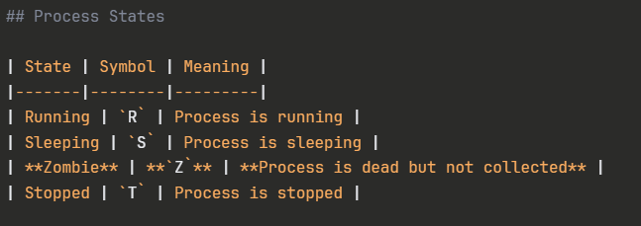
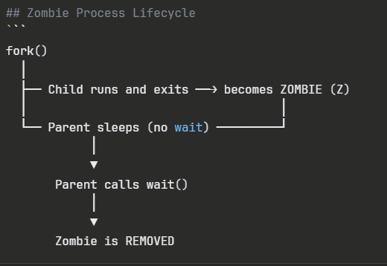
ps aux | grep Z # Zombie processes
ps aux | grep S # Sleeping processes
ps aux | grep R # Running processes
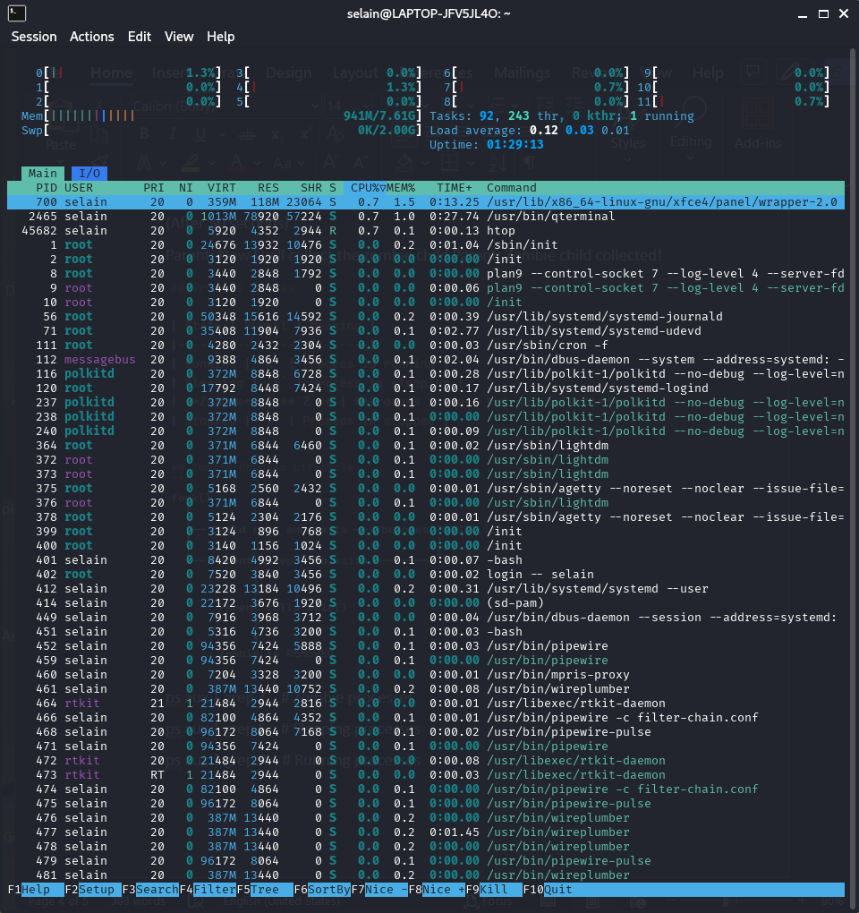
“htop”command (to get out of it type “q”)

“man ps” command then search for PROCESS STATE CODES
